



Telangana tribal welfare residential degree college Girls kumrambheem Asifabad

Mathematics Departmental profile

Presented by

Smt .CH.VasanthA

Lecturer in mathematics

Head dept. of mathematics

CONTENT

I.CURRICULAR ASPECTS

II.BIO DATA OF THE STAFF

III.TEACHING LEARNING PROCESS

iv.student strength particulars last five years

v.career guidelines, departmental achievements

vi.list of class room activities

I.CURRICULAR ASPECTS

**DEPARTMENT HISTORY:**

**The department of mathematics was established in this college with b.sc general course(mpc) in the year 2017-18 with a view to provide science education to the students of this region. Eminent and well experienced faculty served at this department. In a bid to impart the computer knowledge which is the need of the hour, b.sc(mpc&mpcs) was also introduced. To cater to the needs of the english medium students. Many efficient scholars with required knowledge and skills were produced from this department. Alumni members of this department achieved greater Positions In Their Lives. The department is active in research in most areas of pure and applied mathematics, including algebra and number theory, analysis, discrete mathematics, geometry/topology, mathematical finance, numerical analysis, partial differential equations and probability.**

**Vision and Mission of the Department:**

**Vision: To create an enlighten society of educated young minds with scientific temperament, logical analysis and rational thinking.**

**Mission: As we know that every problem has a solution as long as you apply the right formula.**

**Our mission is to prepare the students not only for the three year academic phase but also for**

**The period where they have to struggle individually for their careers and jobs. Our teaching is career based with maximum focus on analytical and practical abilities.**

**EXECUTIVE SUMMARY:**

* Department have conducted a good number of Co-curricular activities such as Employability classes, Student Seminars, Assignment, Extension Lectures, MATHEMATICS Quiz, Field Visits and Study Projects etc. to increase their participant and collaborative learning.
* To support the technology, interestingly effectively using ICT for making the teaching learning more effective.
* During the last five years, a good number of MATHEMATICS students have progressed to higher education i.e., M.Sc. and Other courses they got the central,state,private jobs
* Famous, Educational and Successful Experienced Teachers have served at the Department and molded many students to reach greater heights in their life.
* Department of MATHEMATICS valuable services in various Academic, Administrative, Extension Committee.

**STRENGTHS, OPPORTUNITITES & CHALLENGES:**

**Strengths:**

Well ventilated and spacious classrooms.

Availability of CCTV Camera for safety and security.

We have smart board facility.

**Opportunities:**

There is lot of potential increase for the admissions in the days to come.

P.G Course i.e., M.Sc Mathematics, Data science courses, can be introduced to cater to demands of this region students.

More number of Certificate and Value Added Courses can also be introduced in future.

**Challenges:**

Sever competition from private colleges which are indulging in unfair practices in admissions.

The College is suffering from location problem.

Introduction of P.G course in MATHEMATICS

**ABOUT DEPARTMENT**

The Department of Mathematics was established in the year 2017 with Bsc Mpc . Mpcs courses were introduced in 2018 academic year.

MATHEMATICS is the derived from the Greek word Mathema which means “Knowledge, study, learning”.

Mathematics is the study of numbers and how they are related to each other and to the real world.

Mathematics provides an effective way of building mental discipline and encourages logical reasoning and mental rigor.

**Mathematics helps us have better problem-solving skills.**

II.BIO-DATA OF THE STAFF

**Number of teaching posts**

| LECTURER | SANCTIONED | FILLED |
| --- | --- | --- |
|  | 2 | 2 |
| LECTURER1 work load | 21 |  |
| LECTURER work load | 21 |  |

**Table 2: Details of Qualification of Teaching Faculty during the last five years**

| Year | Name of the Teaching  Faculty | Qualification | Designation | Experience |
| --- | --- | --- | --- | --- |
| 2017-18 | Nandhini Pande | MSC | Lecturer | 1 |
| 2018-19 | Varalaxmi | MSC | Lecturer | 1 |
| 2019-20 | CH. Vasantha | MSC,BE.d | Lecturer | 4 |
| 2020-21 | J. Sumalatha | MSC,BE.d | Lecturer | 1 |
| 2021-22 | K.snehadeeepa | MSC,BE.d | Lecturer | 3 |
| 2022-23 | Ch.vasantha | MSC,BE.d | Lecturer | 4 |

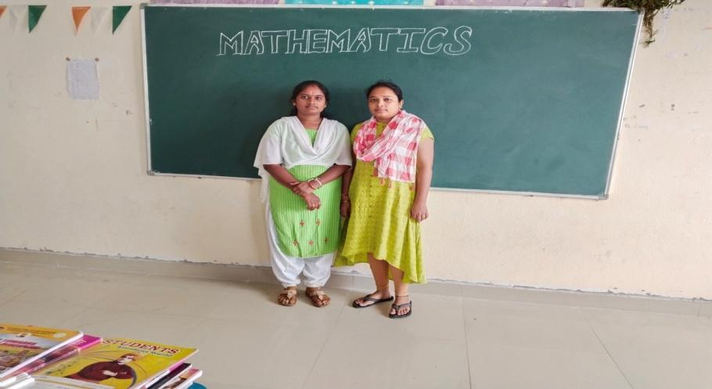

**PROFILE OF FACULTY MEMBER -1**

Name of the faculty : CH.Vasantha

Designation : Lecturer in mathematics

Qualification : MSc, B.Ed.

Total Teaching Experience : 9 years

Date of joining : 21-10-2019

Address : Mandamarri

Mobile number: 9398009846

Present working: Telangana tribal welfare residential degree college Asifabad

Email : [chinthalavasantha13@gmail.com](mailto:chinthalavasantha13@gmail.com)

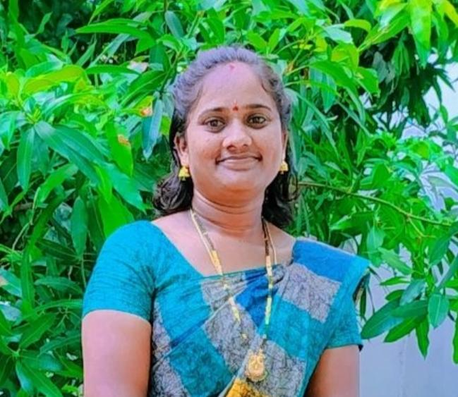

**PROFILE OF FACULTY MEMBER -2**

Name of the faculty : K. Sneha deepa

Designation : Lecturer in mathematics

Qualification : MSc, B.Ed

Total Teaching Experience : 8 years

Date of joining : 22-03-2021

Address : Kagaznagar

Mobile number: 7287821992

Present working: Telangana tribal welfare residential degree college Asifabad

Email : ksnehadepeepak@gmail.com

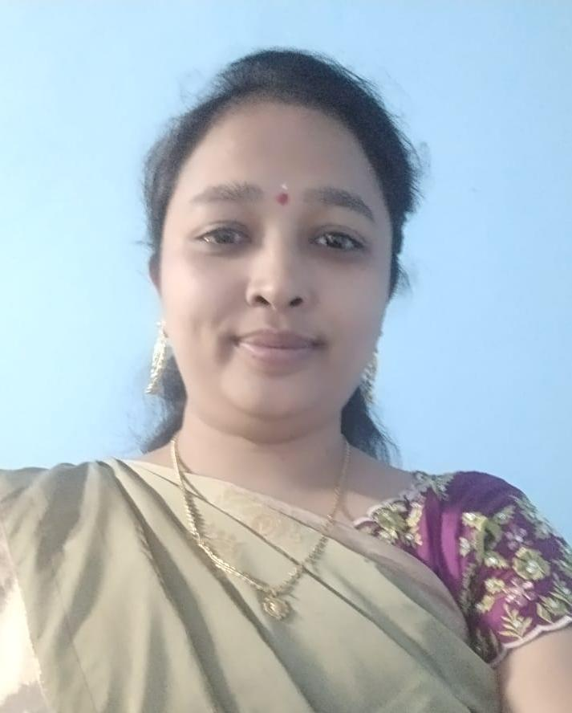

**SYLLABUS DESIGNED**

**The College is affiliated to Kakatiya University and the syllabus is**

**Approved by the Board of studies of the Kakatiya University and**

**Adopted by all Affiliated Colleges of the University. The latest change**

**In the syllabus was done in the year.**

**MATHEMATICS TEXT BOOKS**

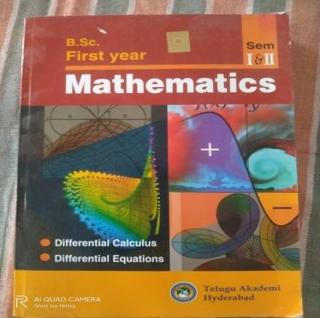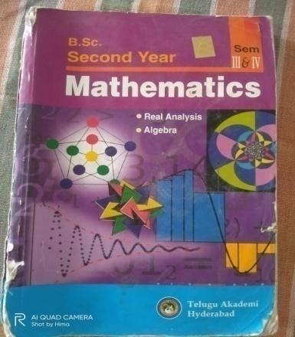

**Second year:sem III, sem IV**

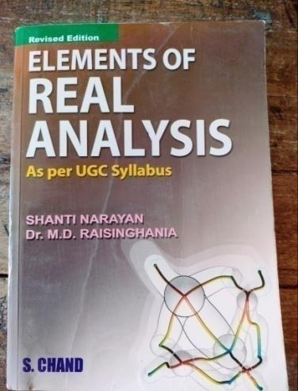

**Second year:semIII**

**1st Year 1st and 2nd Semesters Syllabus**

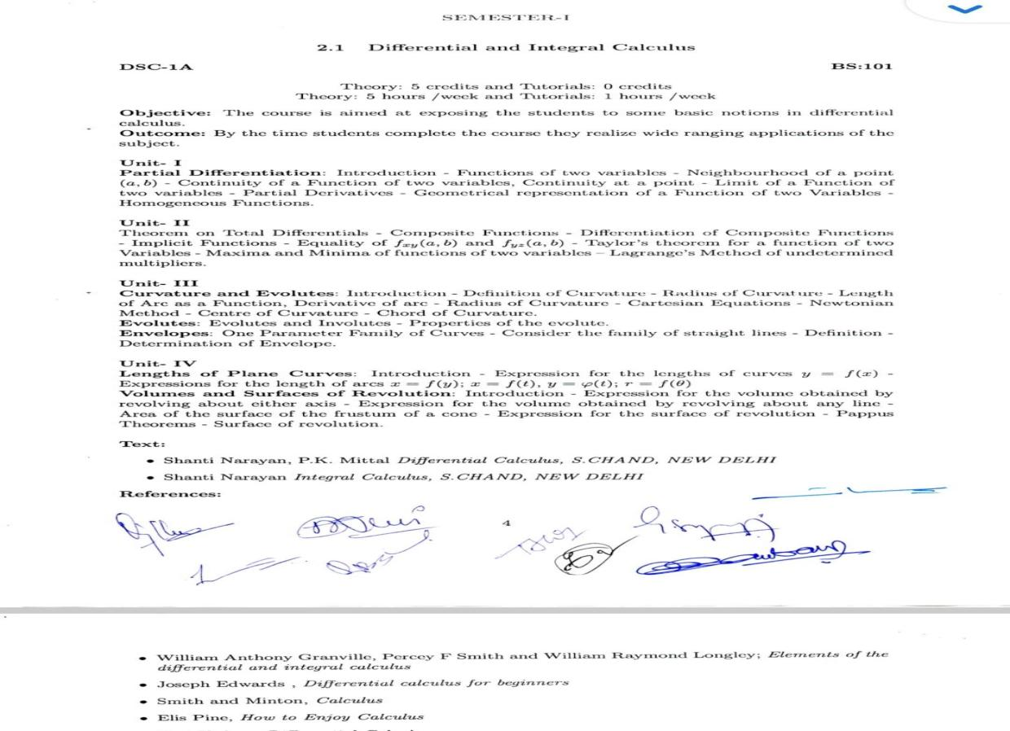

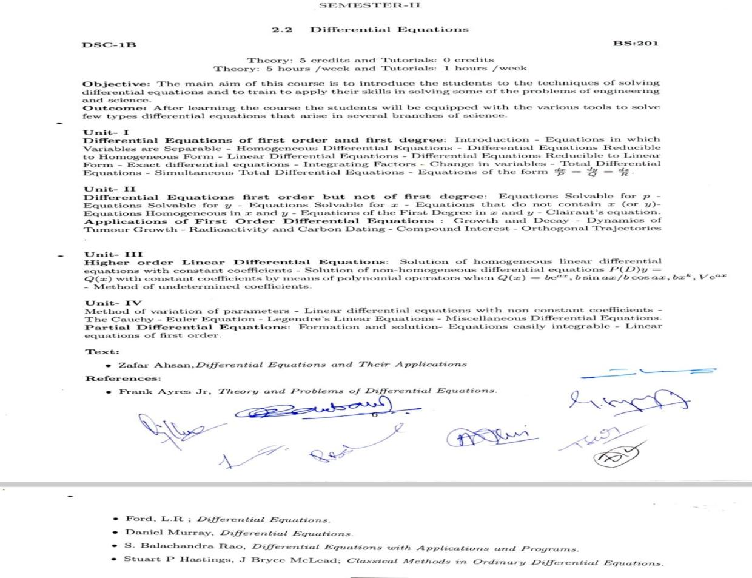

**2nd Year 3rd and 4th Semesters Syllabus**

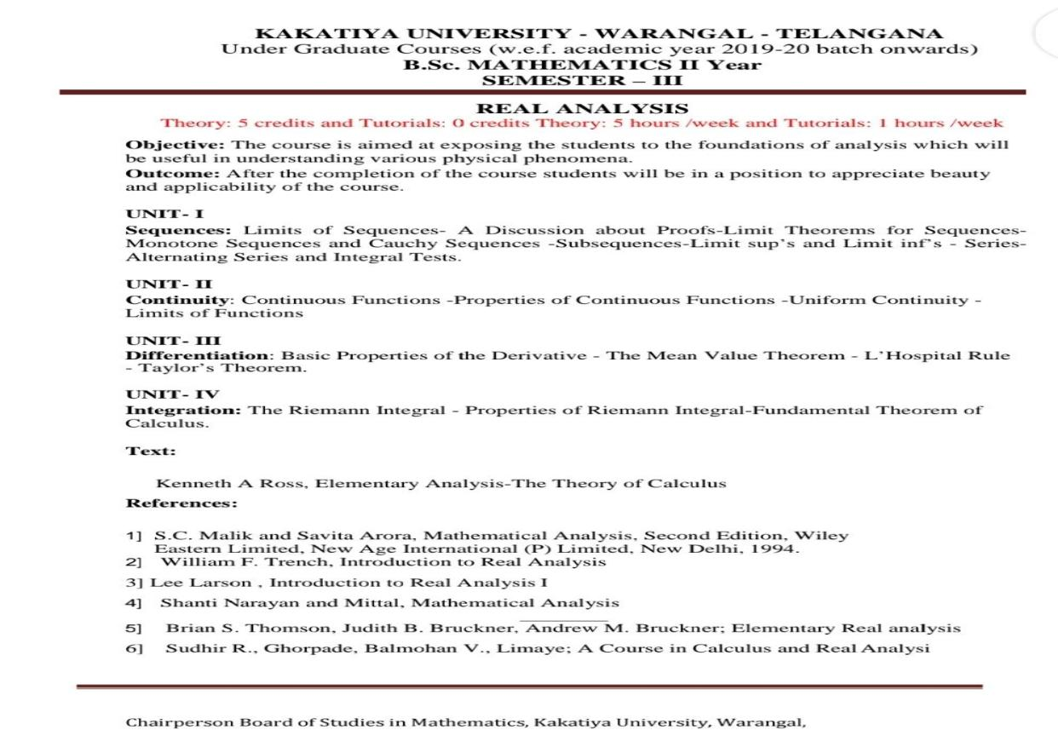

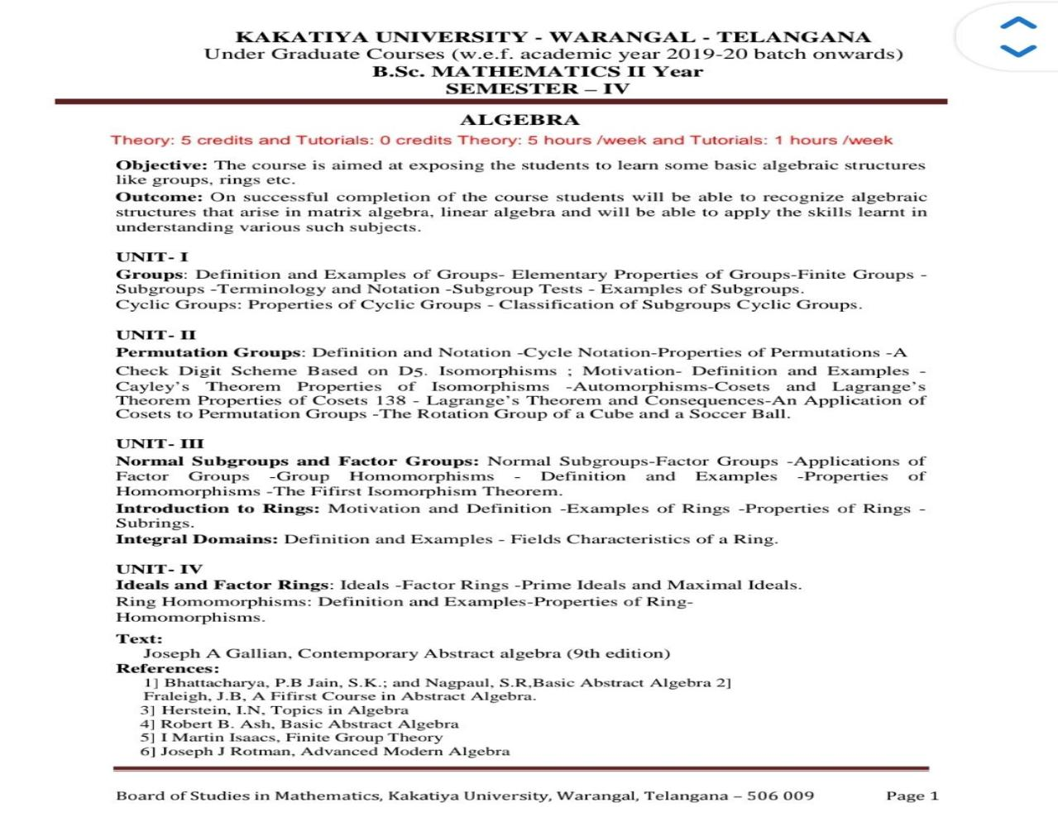

**3rd Year 5th and 6th Semesters Syllabus**

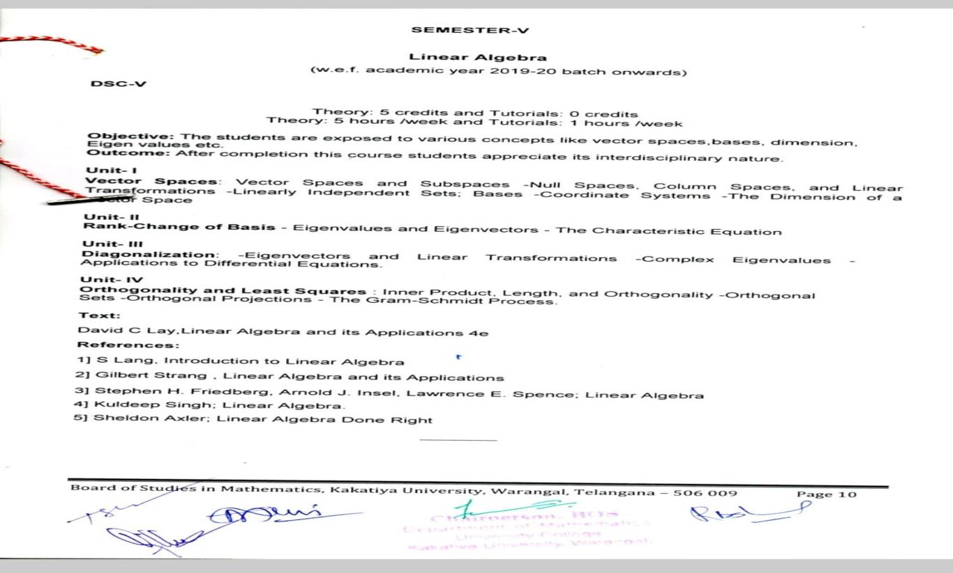

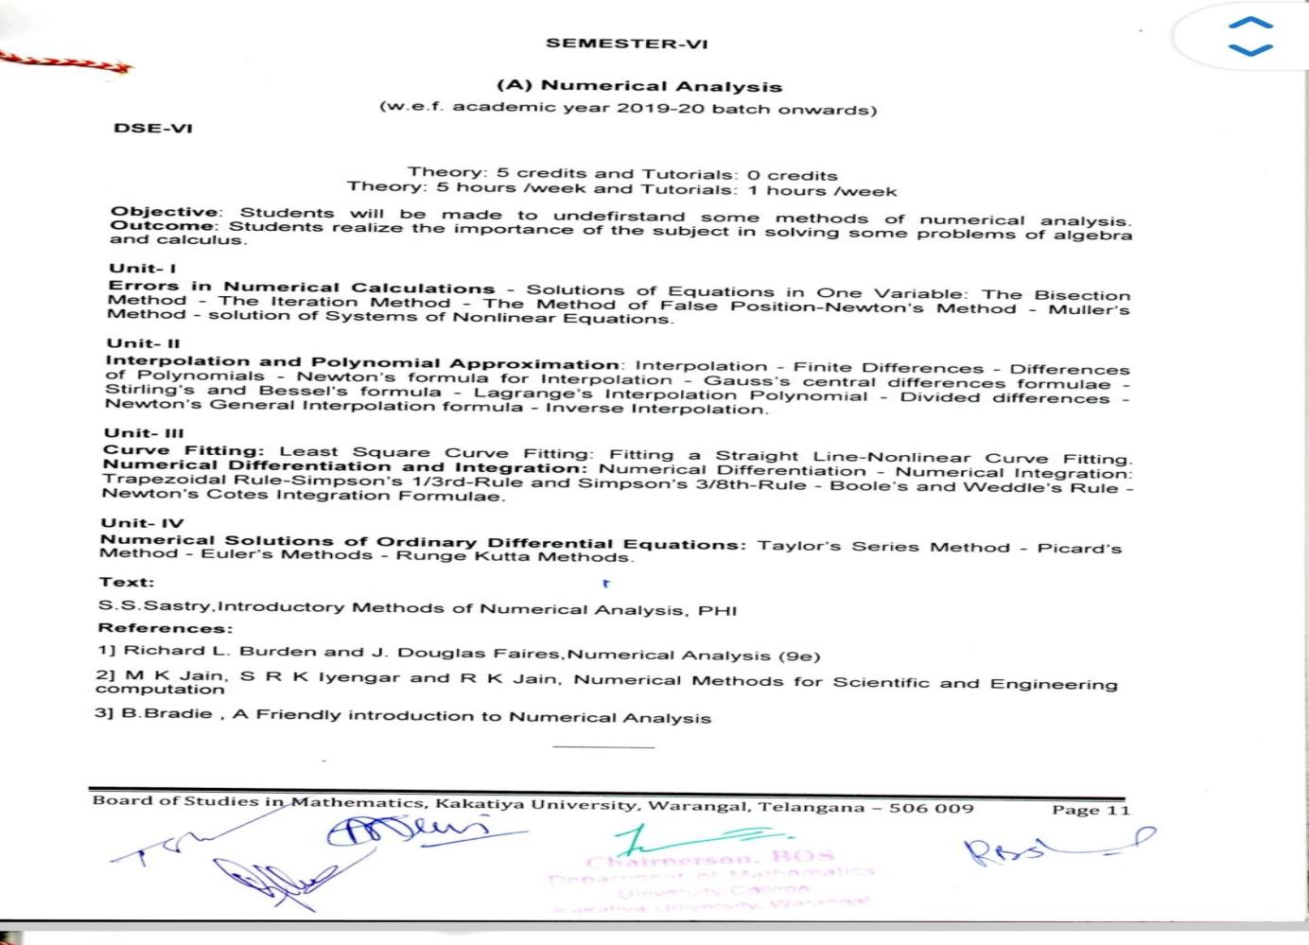

**III.TEACHING LEARNING PROCESS**

* Department prepares Action Plan at the beginning of every academic year.
* Annual Curricular Plan is prepared at the beginning of the Academic Year.
* Departmental Meetings are conducted under the Chairmanship of the Principal.
* Besides Curricular Activities, Co-curricular Activities are planned and implemented.
* Feedback of the Lecturer is taken by the Department and analyzed and reviewed the analysis and accordingly
* Plan the next year teaching Strategies.
* Drills should come after students learn and understanding the basics.
* There should be short practice sessions, and the learner’s progress should be checked often

**TEACHING METHODS**

* Conventional Black Board method
* Discussion Method
* Study projects, Assignments.
* Lecture Method.
* Audio Visual Aids.
* Class Room Seminars.
* Guest Lectures
* Group Discussions.
* Slip Tests.
* Inductive and Deductive
* Heuristic or Discovery
* Analytic and synthetic
* Problem solving
* Laboratory and projects methods

**TGWRDC (G), ASIFABAD KUMRAM BHEEM DIST, T.S-504293**

**DEPARTMENT TIME TABLE-(2022-23)**

| **Day** | **9:10am-10:10am**  **Vasantha&snehadeepa** | 11:10am-12:10pm**Vasantha&snehadeepa** | **12:10pm-1:10pm vasantha** | **2:00pm-3:00pm**  **snehadeepa** | **3:00pm-5:00pm** | **3:00pm-5:00pm** |
| --- | --- | --- | --- | --- | --- | --- |
| **Mon** | Mpcs II and IIIyear | Mpcs I and Mpc III year | Mpc and mpcs-II year | Mpc II year | PG Coaching | Employability coaching |
| **Tue** | Mpcs II and IIIyear | Mpcs I and Mpc III year | Mpc&mpcsIIyear | MpcII year | PG coaching | Employability coaching |
| **Wed** | Mpcs II and IIIyear | Mpcs I and Mpc III year | Mpc & mpcs-II year | MpcII year | PG coaching | Employability coaching |
| **Thu** | Mpcs II and IIIyear | Mpcs I and Mpc III year | Mpc & mpcs-II year | Mpc II year | PG coaching | Employability coaching |
| **Fri** | MpcsII and IIIyear | Mpcs I and Mpc III year | Mpc and mpcs-II year | Mpc II year | PG coaching | Employability coaching |
| **Sat** | Mpcs II and IIIyear | Mpcs I and Mpc III year | Mpc and mpcs-II year | MpcII year | PG coaching | Employability coaching |

| IV.STUDENT STRENTH PARTICULARS FOR LAST FIVEYEARS | | | | | |  |
| --- | --- | --- | --- | --- | --- | --- |
| ACADEMIC YEAR 2017-18 | | | | | | |
| S.NO | Name of the Course | MEDIUM | I Yr | II Yr | III Yr | TOTAL |
| 1 | B.SC(MPC) | E/M | 17 | - | - | 17 |
| ACADEMIC YEAR 2018-19 | | | | | | |
| S.NO | Name of the Course | MEDIUM | I Yr | II Yr | III Yr | TOTAL |
| 1 | B.SC(MPC) | E/M | 14 | 17 | - | 31 |
| 2 | B.SC(MPCs) | E//M | 18 |  | - | 18 |
| TOTAL | |  | 32 | 17 | - | 49 |
| ACADEMIC YEAR 2019-20 | | | | | | |
| S.NO | Name of the Course | MEDIUM | I Yr | II Yr | III Yr | TOTAL |
| 1 | B.SC(MPC) | E/M | 19 | 14 | 17 | 50 |
| 2 | B.SC(MPCs) | E/M | 23 | 18 | - | 41 |
|  | Total |  | 42 | 32 | 17 | 91 |
| ACADEMIC YEAR 2020-21 | | | | | | |
| S.NO | COURSE | MEDIUM | I YR | II YR | III YR | TOTAL |
| 1 | B.SC(MPC) | E/M | 19 | 19 | 12 | 50 |
| 2 | B.SC(MPCs) | E/M | 23 | 23 | 17 | 63 |
|  | TOTAL |  | 42 | 42 | 29 | 113 |
| ACADEMIC YEAR 2021-22 | | | | | | |
| S.NO. | COURSE | MEDIUM | I YR | II YR | III YR | TOTAL |
| 1 | B.SC(MPC) | E/M | 22 | 12 | 17 | 51 |
| 2 | B.SC(MPCs) | E/M | 33 | 12 | 22 | 67 |
|  | Total |  | 55 | 24 | 39 | 118 |
| ACADEMIC YEAR 2022-23 | | | | | | |
| S.NO. | COURSE | MEDIUM | I YR | II YR | III YR | TOTAL |
| 1 | B.SC(MPC) | E/M | 19 | 19 | 11 | 49 |
| 2 | B.SC(MPCs) | E/M | 20 | 31 | 12 | 63 |
|  | Total |  | 39 | 50 | 23 | 112 |

| **TELANGANA TRIBAL WELFARE RESIDENTIAL DEGREE COLLEGE FOR WOMEN** | | | | |
| --- | --- | --- | --- | --- |
| **ASIFABAD** | | | |  |
| **DEPARTMENT OF MATHEMATICS** | | | |  |
| **Academic Result Analysis Individual CH.VASANTHA** | | | |  |
| **Semester III&V 2019-2020** | | | | |
| **Group** | **Appeared** | **Pass** | **Pass Percentage** | |
| MpcVSEM | 17 | 14 | 82 | |
| MpcIIISEM | 14 | 12 | 86 | |
| MpcsIIISEM | 17 | 14 | 82 | |
| MpcVISEM | 17 | 17 | 100 | |
| MpcIVSEM | 14 | 13 | 93 | |
| MpcsIVSEM | 17 | 16 | 94 | |

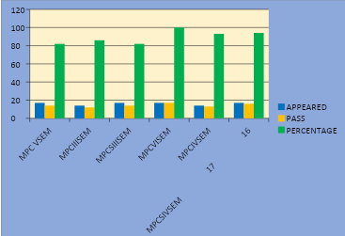

| **TELANGANA TRIBAL WELFARE RESIDENTIAL DEGREE COLLEGE FOR WOMEN** | | | | |
| --- | --- | --- | --- | --- |
| **ASIFABAD** | | | |  |
| **DEPARTMENT OF MATHEMATICS** | | | |  |
| **Academic Result Analysis Individual CH.VASANTHA** | | | |  |
| **2020-2021** | | | | |
| **Group** | **Appeared** | **Pass** | **Pass Percentage** | |
| MpcsIIISEM | 23 | 21 | 91 | |
| MpcIIISEM | 19 | 19 | 100 | |
| MpcsVSEM | 17 | 17 | 100 | |
| MpcVSEM | 14 | 14 | 100 | |
| MpcsIVSEM | 23 | 23 | 100 | |
| MpcIVSEM | 19 | 14 | 74 | |
| MpcsVISEM | 17 | 17 | 100 | |
| MpcVISEM | 14 | 14 | 100 | |

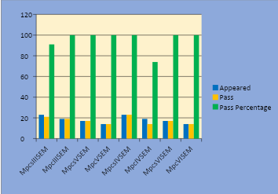

| **TELANGANA TRIBAL WELFARE RESIDENTIAL DEGREE COLLEGE FOR WOMEN** | | | | | |
| --- | --- | --- | --- | --- | --- |
| **ASIFABAD** | | | | |  |
| **DEPARTMENT OF MATHEMATICS** | | | | |  |
| **Academic Result Analysis CH.VASANTHA&K.SNEHADEEPA** | | | | | 2020-2021 |
| **Group** | **Year** | **Appeared** | **Pass** | **Fail** | **Pass%** |
| Mpcs | I | 31 | 17 | 14 | 55 |
| Mpc | I | 24 | 18 | 6 | 75 |
| Mpcs | II | 46 | 44 | 2 | 96 |
| Mpc | II | 38 | 33 | 5 | 87 |
| Mpcs | III | 68 | 68 | - | 100 |
| Mpc | III | 48 | 48 | - | 100 |

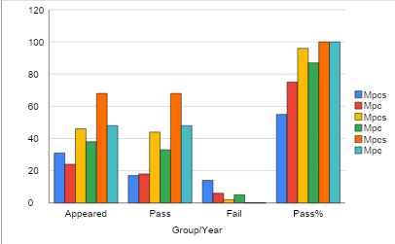

| **TELANGANA TRIBAL WELFARE RESIDENTIAL DEGREE COLLEGE FOR WOMEN** | | | | | |
| --- | --- | --- | --- | --- | --- |
| **ASIFABAD** | | | | |  |
| **DEPARTMENT OF MATHEMATICS** | | | | |  |
| **Academic Result Analysis CH.VASANTHA&K.SNEHADEEPA** | | | | |  |
| **2021-22** | | | | | |
| **Group** | **Year** | **Appeared** | **Pass** | **Fail** | **Pass%** |
| Mpcs | I | 65 | 50 | 15 | 78 |
| Mpc | I | 40 | 32 | 8 | 80 |
| Mpcs | II | 26 | 20 | 6 | 77 |
| Mpc | II | 24 | 18 | 5 | 75 |
| Mpcs | III | 45 | 44 | 1 | 98 |
| Mpc | III | 34 | 25 | 9 | 74 |

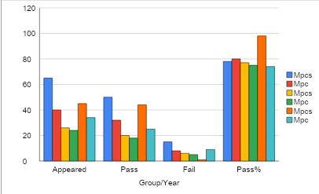

| **TELANGANA TRIBAL WELFARE RESIDENTIAL DEGREE COLLEGE FOR WOMEN** | | | | | |
| --- | --- | --- | --- | --- | --- |
| **ASIFABAD** | | | | |  |
| **DEPARTMENT OF MATHEMATICS** | | | | |  |
| **Academic Result Analysis CH.VASANTHA&K.SNEHADEEPA** | | | | | 2020-2021 |
| **2022-23** | | | | | |
| **Group** | **Year** | **Appeared** | **Pass** | **Fail** | **Pass%** |
| Mpcs | I | 38 | 25 | 13 | 66 |
| Mpc | I | 32 | 20 | 12 | 63 |
| Mpcs | II | 61 | 23 | 38 | 38 |
| Mpc | II | 38 | 16 | 22 | 42 |
| Mpcs | III | 24 | 21 | 3 | 88 |
| Mpc | III | 22 | 19 | 3 | 86 |

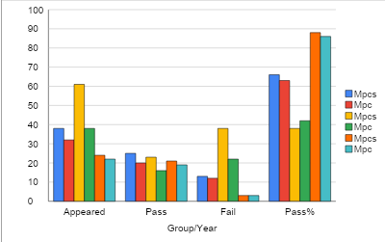

**LECTURER TO STUDENT RATIO**

Total no. of Lecturers : 2

Total no. of. Students (2021-22 Academic Year) : 112

Lecturer Student Ratio :56:2

STUDENT CENTRIC LEARNING

* Teaching through PPT’s.
* Regular Co-curricular Activities
* The Department has provided study material.
* Project Works are given to the students.

There should be practice sessions, drills should be different, and each student

should be Able to do drills in a way that is useful to them.

**v.CAREER GUIDELINES, DEPARTMENTAL ACHIEVE MENTS**

**CAREER GUIDELINES**

The Department of Mathematics encourages the students for their future careers. The faculty is the in-charge guided for P**G Courses and other job oriented programme like data science, government jobs**. The regular students are also enlighten with job Opportunities and other career prospects. Many students have benefited from this average percentage of placement of outgoing students during the last five years

DEPARTMENTAL ACHIEVE MENTS

| **Year** | **Name of student placed and contact details** | **Program graduated from** | **Name of the employer with contact details** | **Pay package at appointment (In INR per annum)** |
| --- | --- | --- | --- | --- |
| **2022** | **Jaansuhana** | **BscMpcs** | **Jaansuhana (9908184384)** | **17900** |
| **2023** | **MuddamPujitha** | **BscMpcs** | **MuddamPujitha(9347819740** | **21000** |
| **2023** | **K.Sathvika** | **BscMpc** | K.Sathvika(9676960196) | 21000 |
| 2017 | A.Indra | **BscMpc** | A.Indra(7702513467) | 28000 |
| 2017 | K.RAJESHWARI | **BscMpc** | K.RAJESHWARI(7093392044) | 28000 |
| 2017 | J.USHARANI | **BscMpc** | J.USHARANI( | 28000 |
| 2017 | J.SRIDEVI | **BscMpc** | J.SRIDEVI | 21000 |

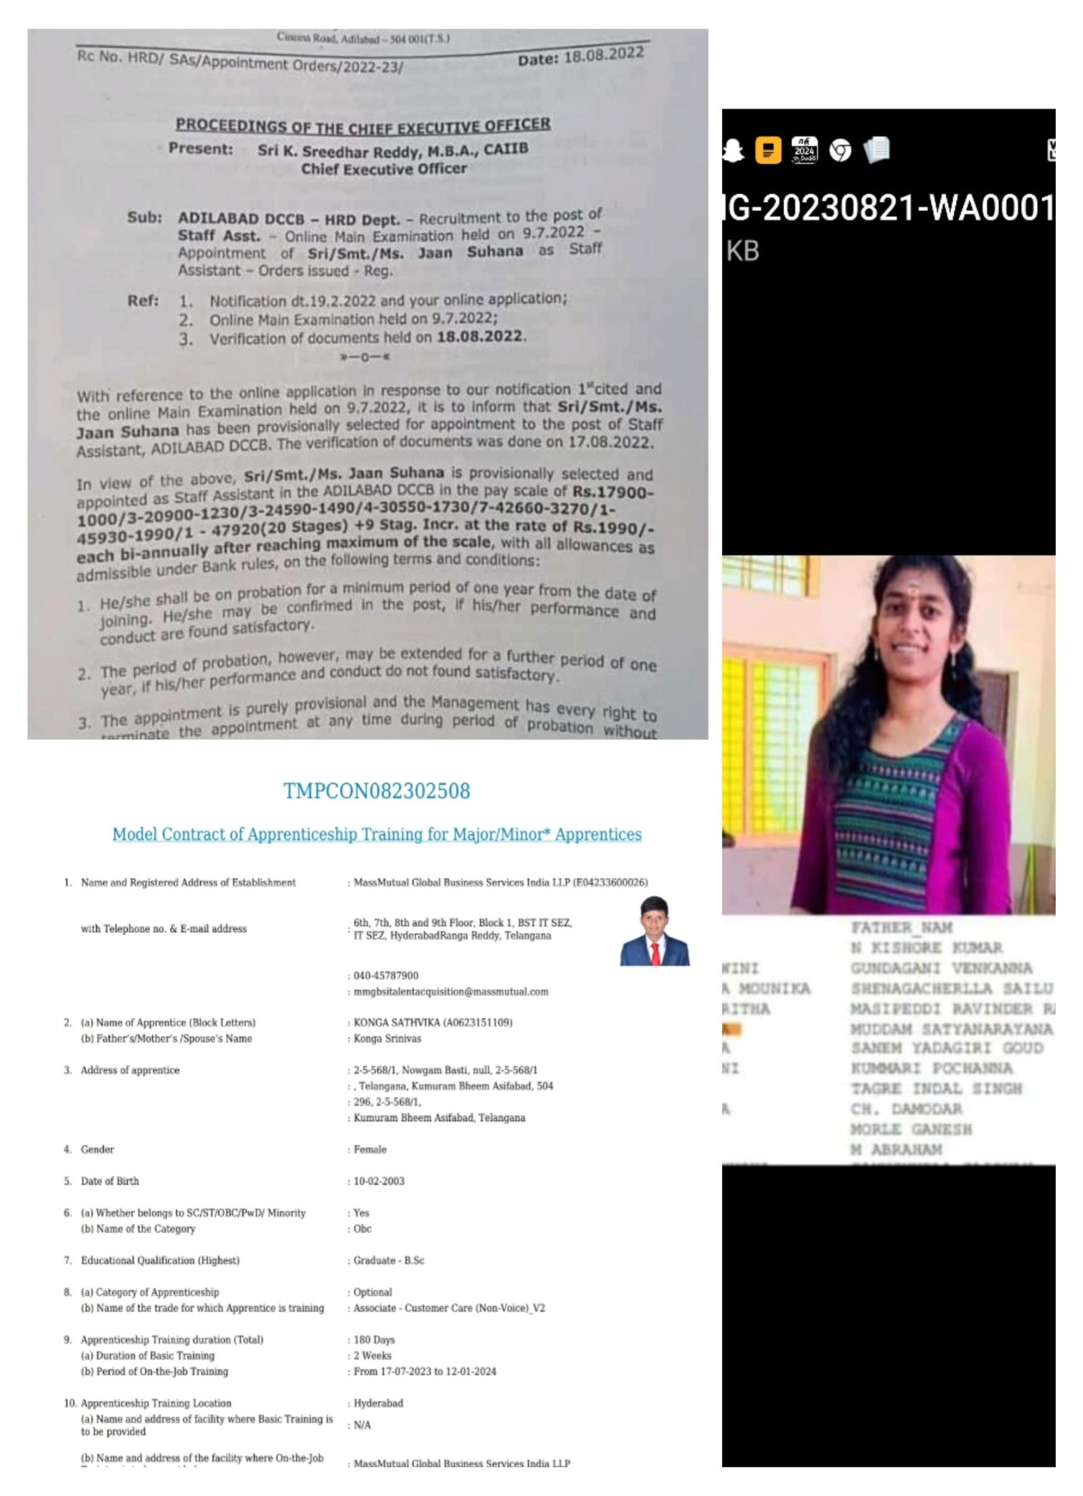

**EFFORTS TO IMPROVE RESULTS**

* Assignments on different topics, To providing good Question banks
* Previous Question papers supply and faculty maintain their Studies.
* Written material supply.
* Encourage every student in studies before exams.

**LEARNING RESOURCES**

* The Department of Mathematics regularly recommends the college library latest books and references books.
* Every year new books are added and since last five years books written by the best authors were procured.

**PARTICIPATION E-CERTIFICATES: CH.VASANTHA**

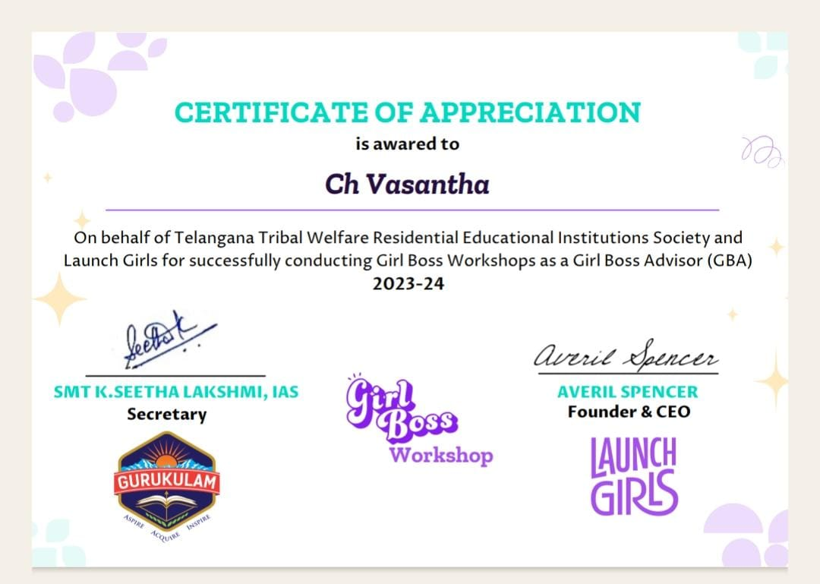

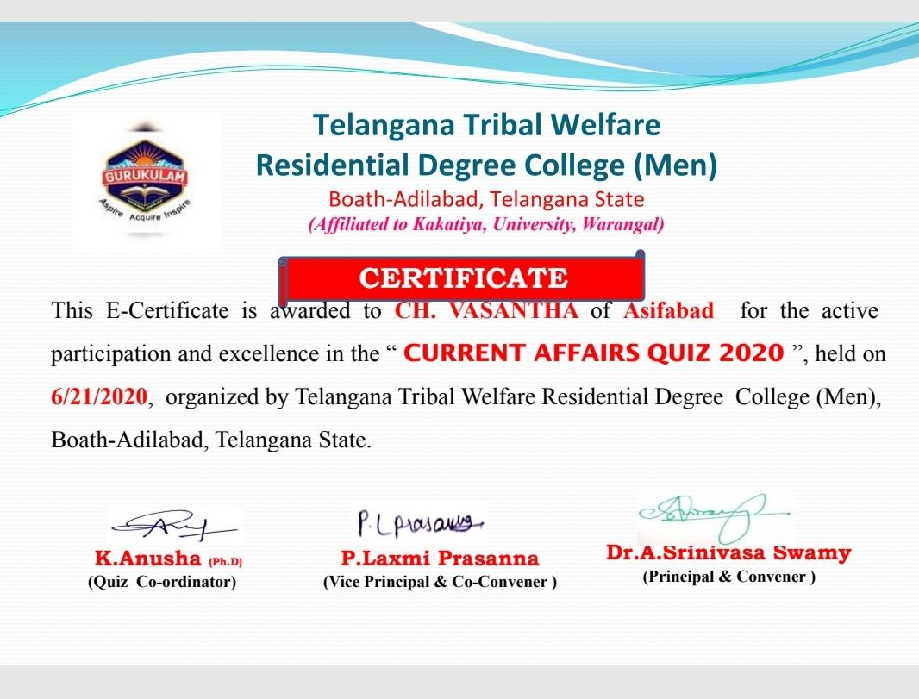

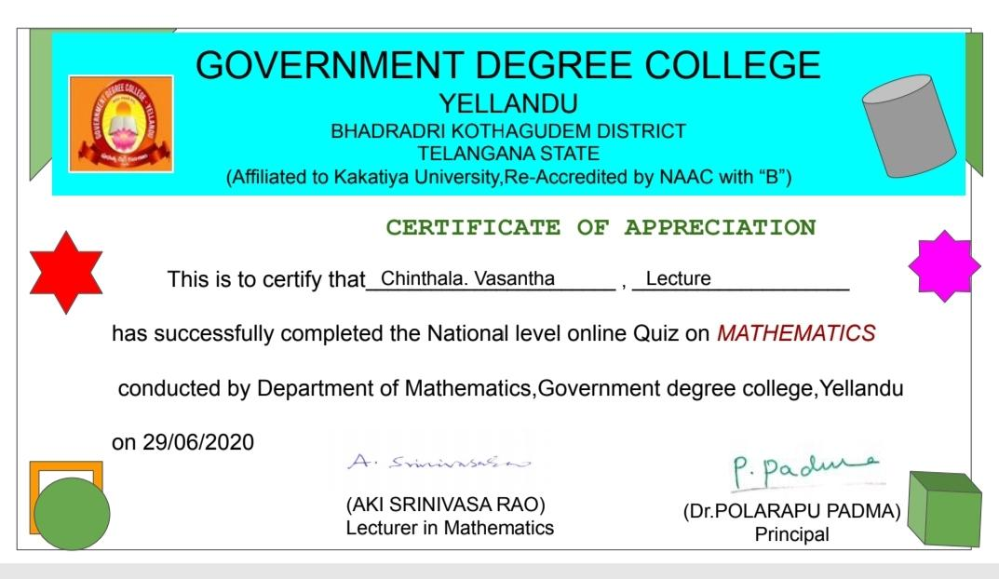

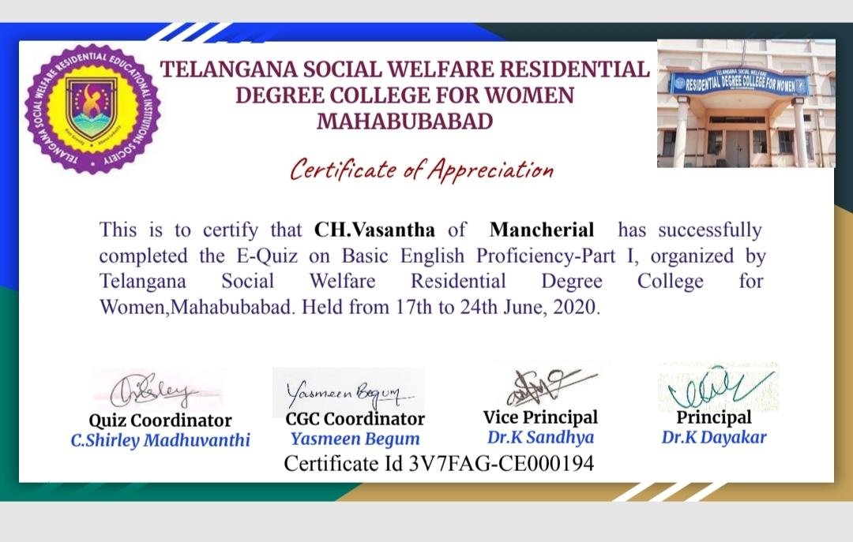

*EXTENSION LECTURER*

*N*ame *: K.Snehadeepa*

*Topic: Riemann Integration*

*Date:18/04/2023*

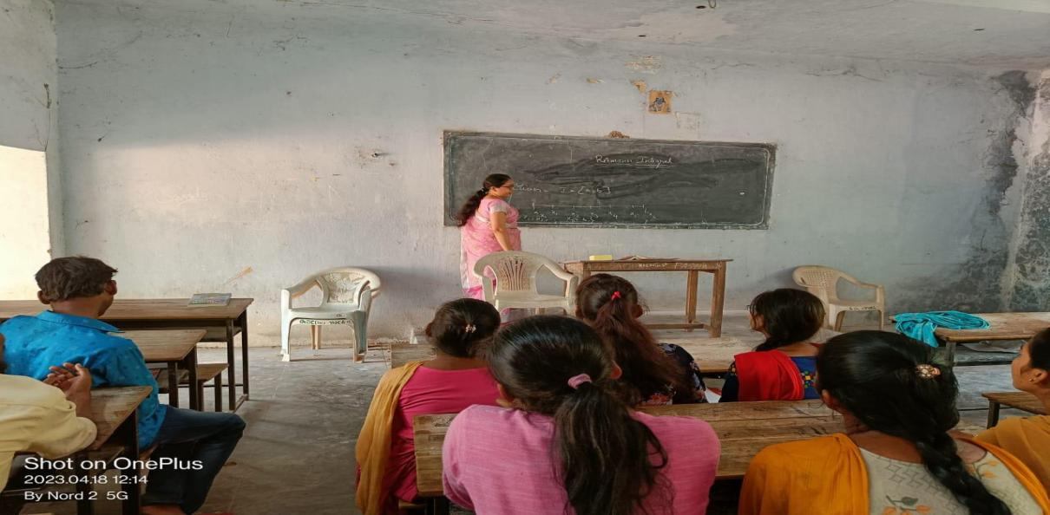

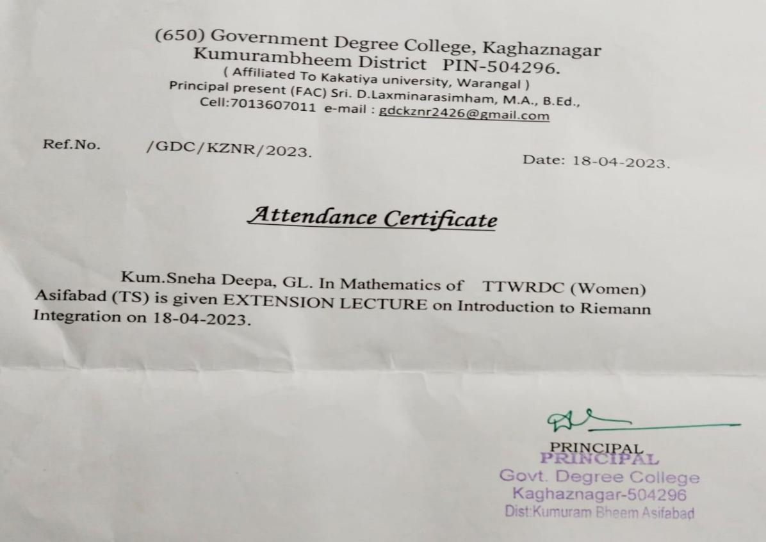

vi.list of class room activities

*MATHEMATICS SEMINAR*

**Department of MATHEMATICS Conducted a seminar with mpc I, II,III Year Students .**

**P.SUVARNA Delivered her seminar on the topic SEQUENCES. All the students are participated**

**in this seminar. It is to help students develop their mathematical communications skills,**

**Acquirement of knowledge in Particular field. Seminar provides a chance to students to learn**

**about the latest Teaching Methods and new teaching skills related to the concerned topic in**

**MATHEMATICS.**

**2019-2023**

| **SNO** | **STUDENT NAME** | **TOPIC** |
| --- | --- | --- |
| **01** | **P.SUVARNA** | **SEQUNCES** |
| **02** | **G.SUJATHA** | **SEQUNCES** |
| **03** | **A.PARVATHI** | **SERIES** |
| **04** | **D.PARVATHI** | **SERIES** |

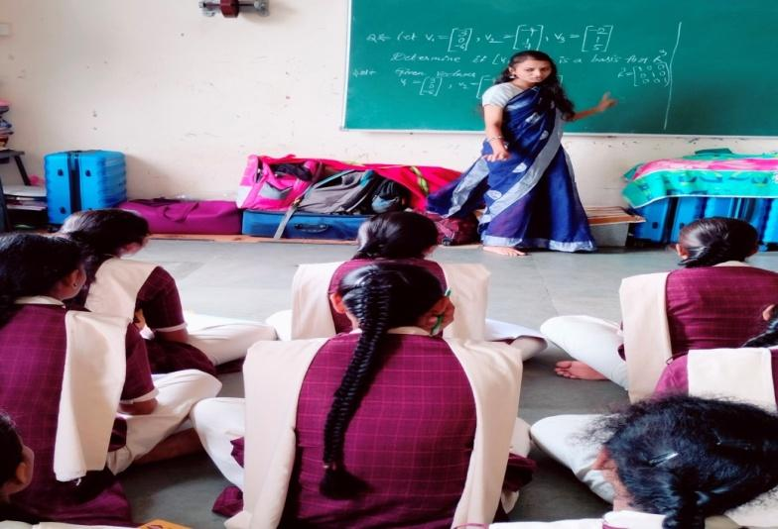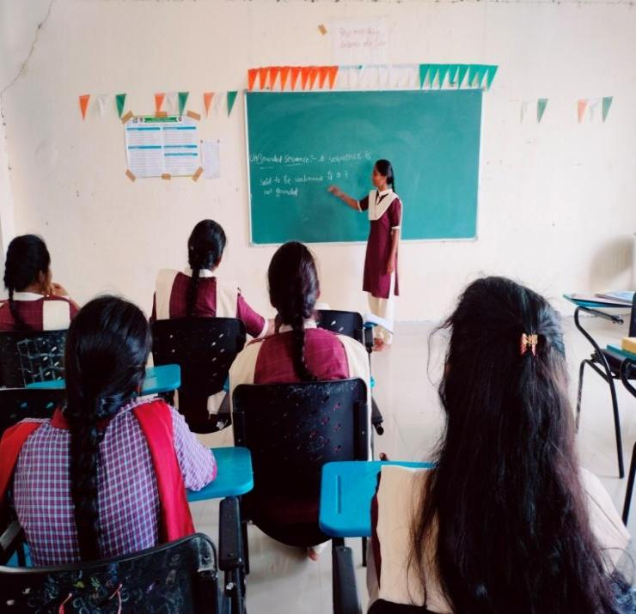

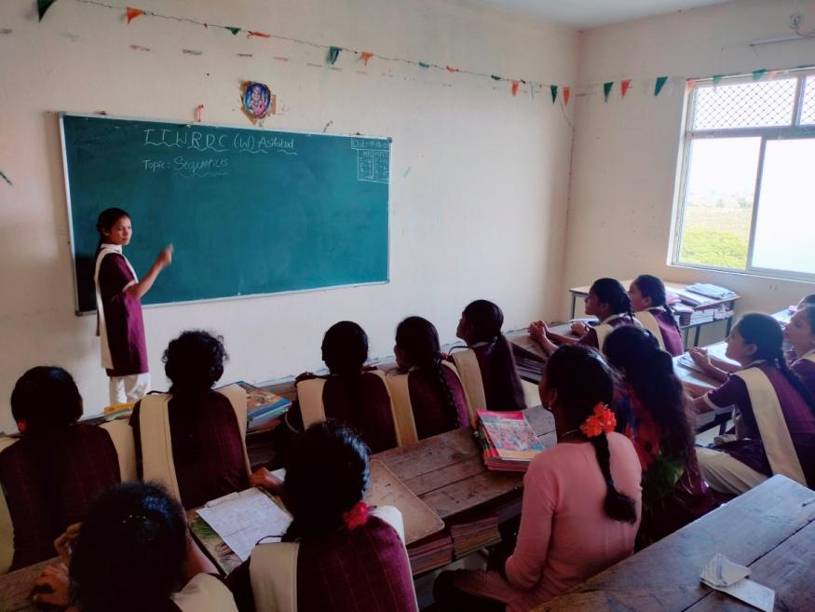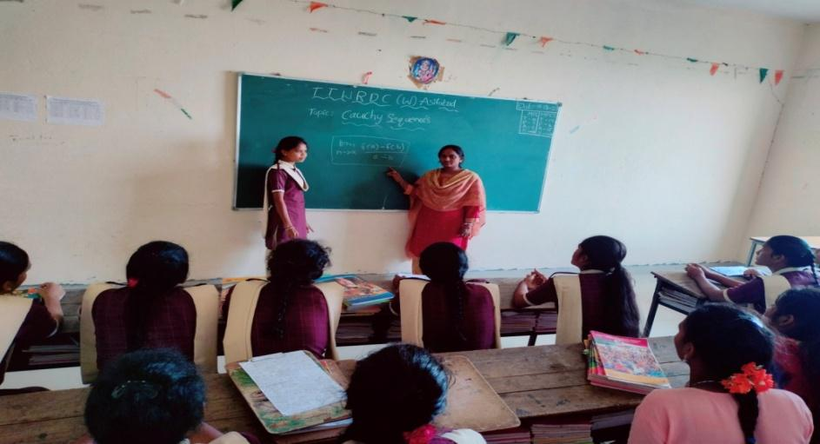

**MATHEMATICS QUIZ**

Department of MATHEMATICS, TGTWRDC GIRLS ASIFABAD conducted quiz competition on Differential Equations for BSC, MPC and MPCS students in the college.

In this competition 2 groups name A,B are participated in the above quiz . B GROUP showed good performance. They are the winners of this quiz competition.

| **WINNER TEAM OF QUIZ COMPETITION**  **MPC** | **RUNNER TEAM OF QUIZ COMPETITION**  **MPCS** |
| --- | --- |
| **A.VIJAYALAXMI** | **A.MEENAKSHI** |
| **D.SAMATHA** | **A.NAGAMANI** |
| **G.SHIRISHA** | **P.RICHA** |
| **P.POOJA** | **J.SUHANA** |
| **K.POOJA** | **G.MALLESWARI** |
| **G.KEERTHANA** | **A.SHOBHA** |
| **J.VANDANA** | **D.SUSHMITHA** |
| **K.JYOSHNA** | **G.SAI SRUTHI** |
| **M.POOJITHA** | **P.NEELA** |
| **H.SONI** | **T.CHITTI** |
| **A.SOMBAI** | **A.NAGAMANI** |
| **CH.SUPRIYA** | **J.GOPIKA** |
| **L.MOUNIKA** | **J.SHARADA** |
| **R.SONALI** | **M.CHANDANA** |
| **P.SHESHIREKHA** | **K.PULAVATHI** |
| **K.YAMUNA** | **M.SUVARNA** |
| **G.SUJATHA** | **K.YAMUNA** |
| **D.SUVARNA** | **A.SOMBAI** |
| **K.CHANDRAKALA** | **CH.SUPRIYA** |

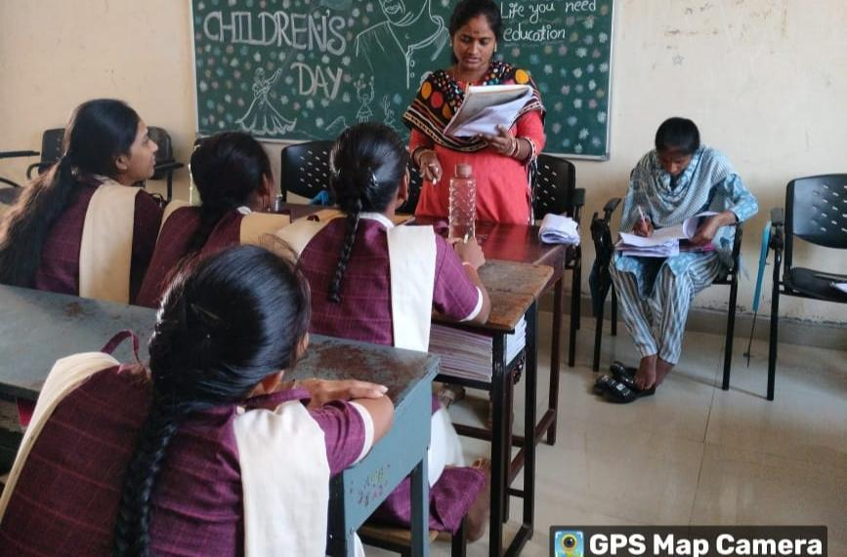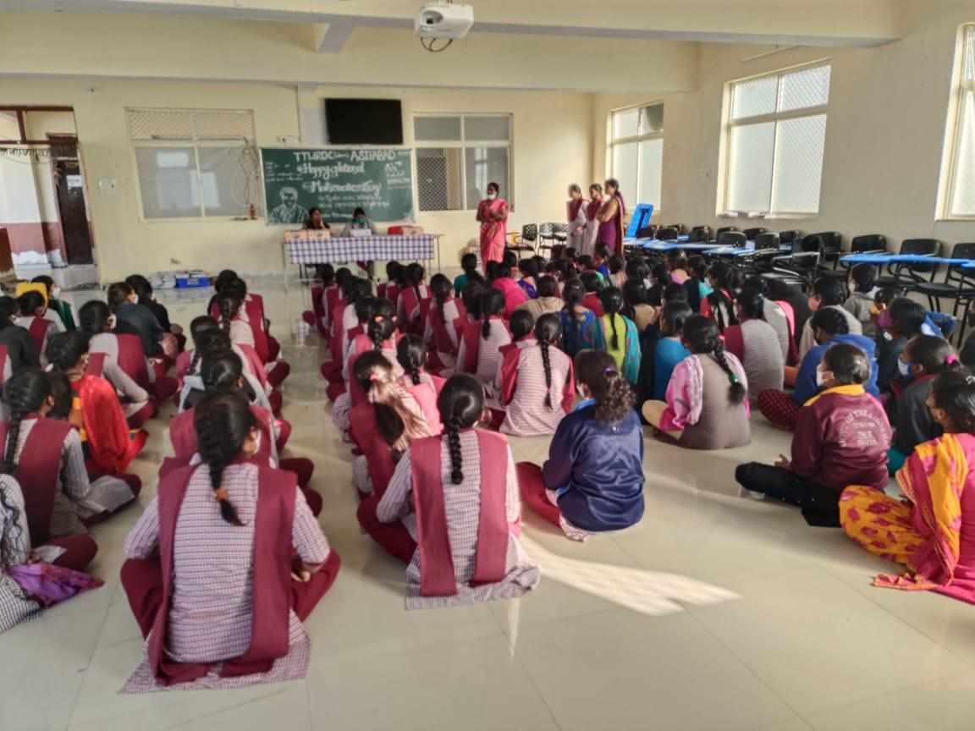

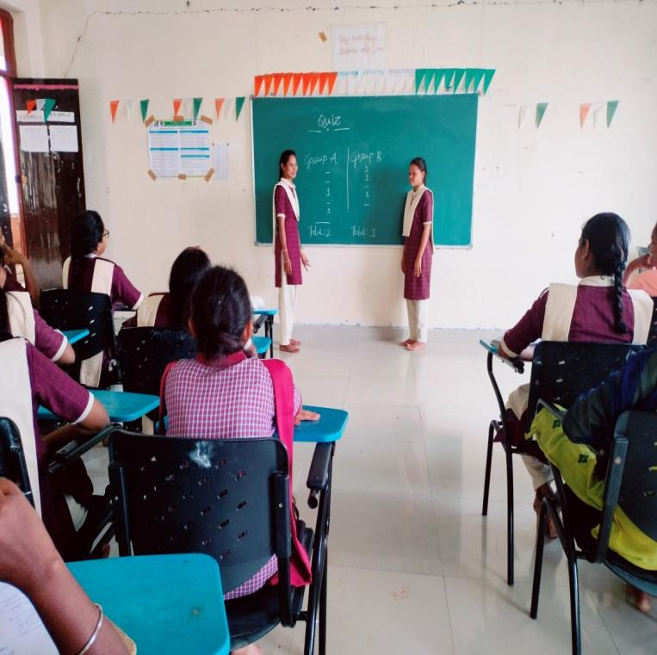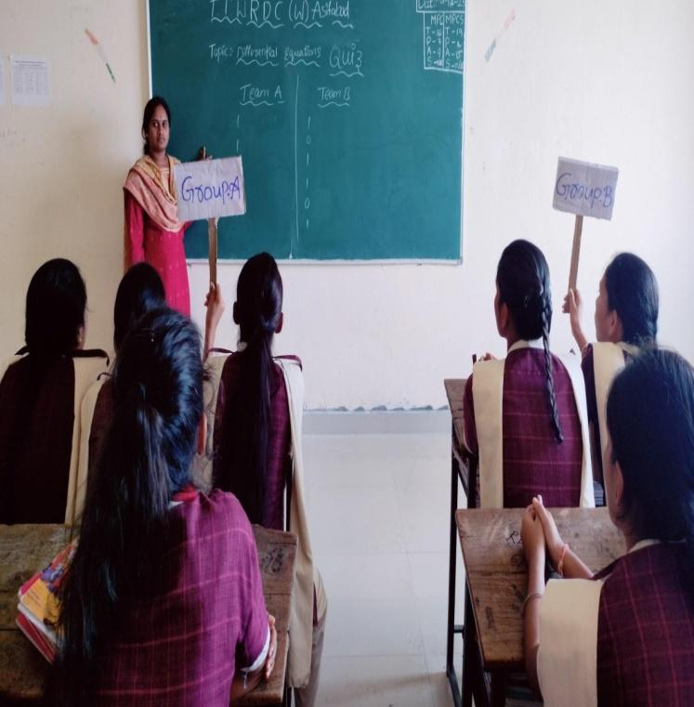

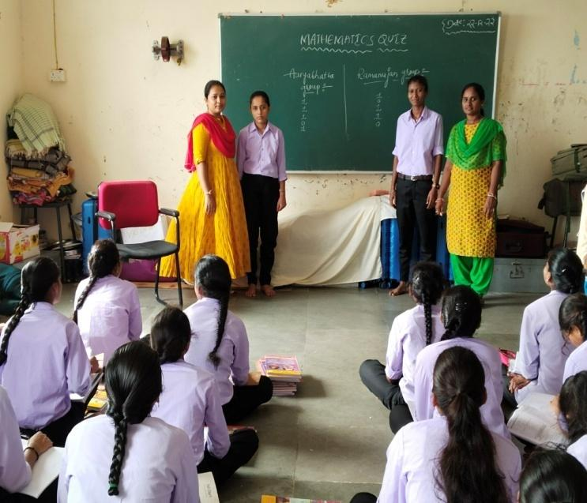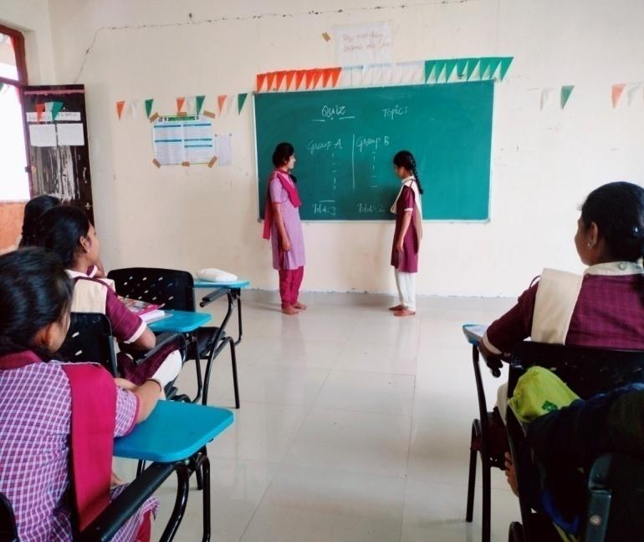

**PROJECT WORK**

1. Introduction Consider an initial value problem
2. Y’ (x) = f(x, y(x)), y(0) = y0 ________________1

To approximate the value y(t) many numerical algorithms such Runge-Kutta methods make computations for a set of points chosen on the interval [0,t].

**2.Standard Euler Integration**

**5.Conclusion**

We have seen how to successfully apply the adaptive step size methods to Euler integration making it more computationally effective. Similar but more advanced techniques can be applied to more efficient numerical methods such as Runge-Kutta to develop adaptive step size algorithms such as Runge-Kutta-Fehlberg and Dormand-Prince methods which are used in practice. For example, Dormand-Prince method is used in one of the Mat lab ordinary differential equation solvers.

**Participated students list:**

| **SNO** | **NAME** | **GROUP** |
| --- | --- | --- |
| 1 | Chandana | Mpc |
| 2 | Sonali | Mpc |
| 3 | Shahera | Mpcs |
| 4 | Bavani | Mpcs |
| 5 | Sharadha | Mpcs |

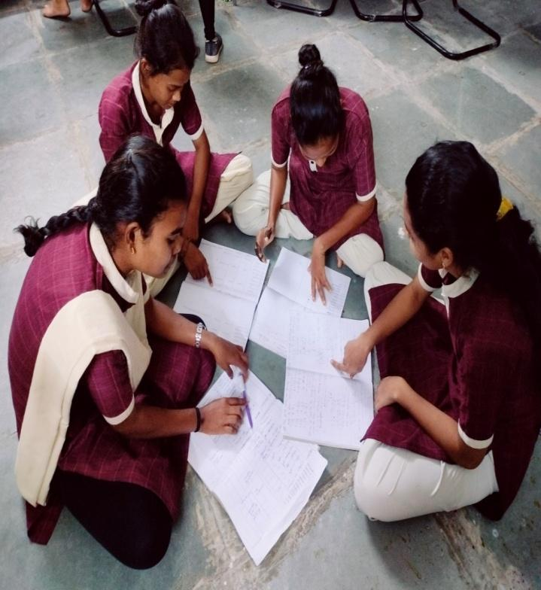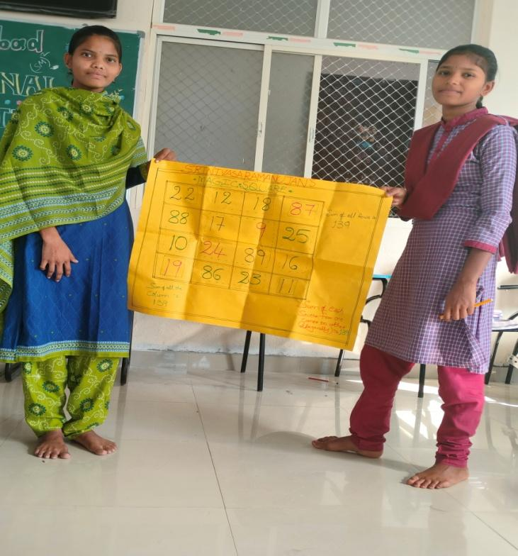

**NAME OF THE FACULTY - CH.VASANTHA**

**2019-2020**

| **S.NO.** | **Committee** | **Member** |
| --- | --- | --- |
| 01 | Mathematics Department | Head of the department |
| 02 | House parent B.com(CA) | Member |
| 03 | Career Guidance Cell | Member |

**2020-2021**

| **S.No.** | **Committee** | **Member** |
| --- | --- | --- |
| 01 | Mathematics Department | Head of the department |
| 02 | House parent B.com(CA) | Member |
| 03 | Career Guidance Cell | Member |
| 04 | Dost | Member |

**2021-2022**

| **S.No.** | **Committee** | **Member** |
| --- | --- | --- |
| 01 | Mathematics Department | Head of the department |
| 02 | House parent Bsc Mpc | Member |
| 03 | Dost | Member |
| 04 | Exam Branch | Member |

**2022-23**

| **S.NO.** | **Committee** | **Member** |
| --- | --- | --- |
| 01 | Mathematics Department | Head of the department |
| 02 | House parent Bsc BZC | Member |
| 03 | Dost | Member |
| 04 | Career Guidance Cell | Member |
| 05 | Anti Ragging Committee | Member |

**WE HAVE THE ADDITIONAL WORK RELATED TO THE COLLEGE**

**PHOTO GALARY ADMISION CAMPAIG**

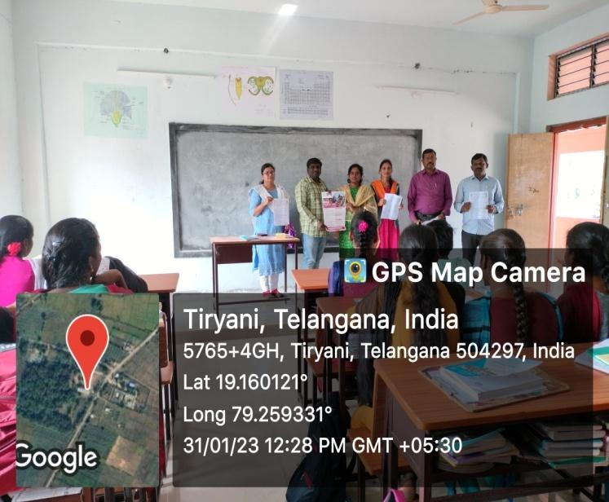 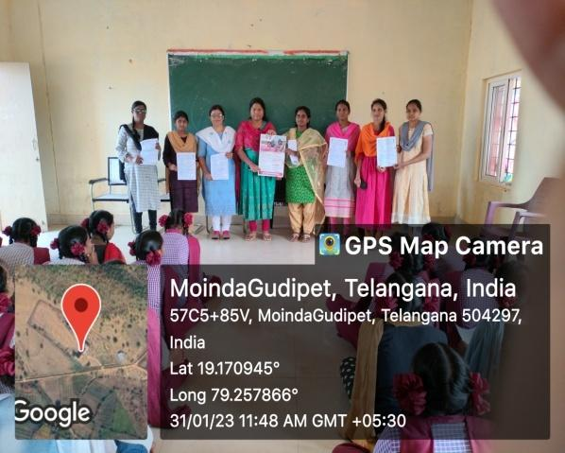

**ALUMNI MEETING (CRITERIA-5) STUDENT COUNCIL ELECTIONS**

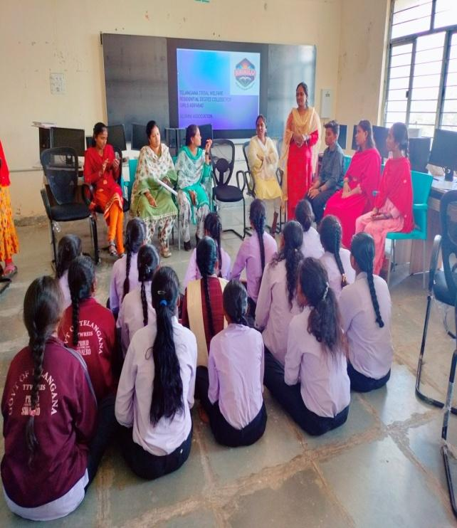 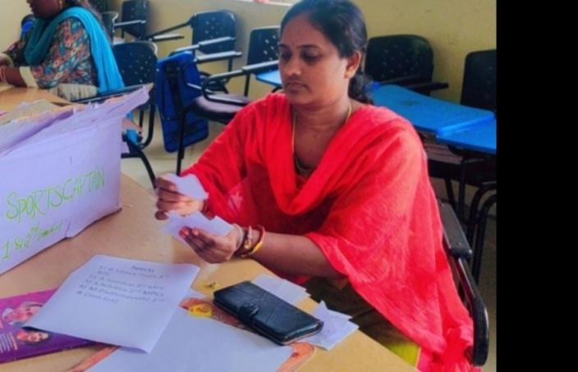

**MENTAR-MENTEE**

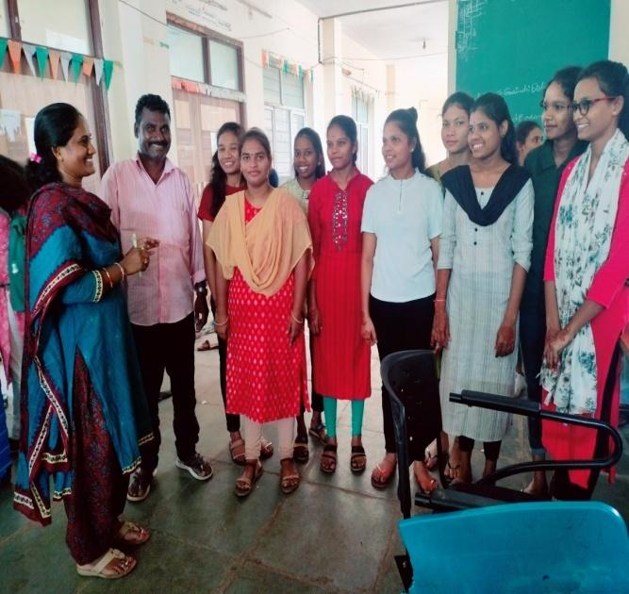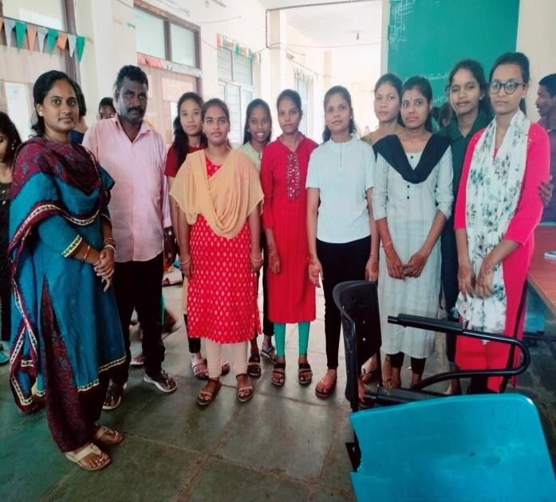

**PARTICIPATING COLLEGE ACTIVITIES MATHEMATICS DAY CELEBRATION**

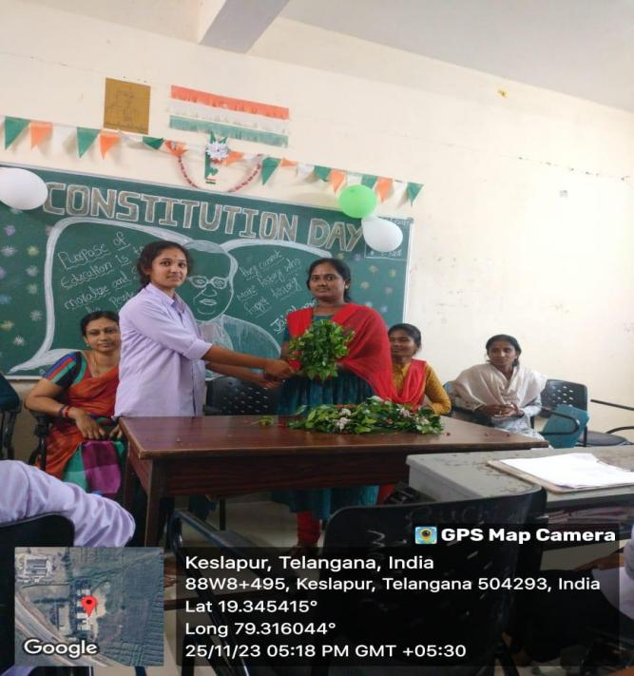 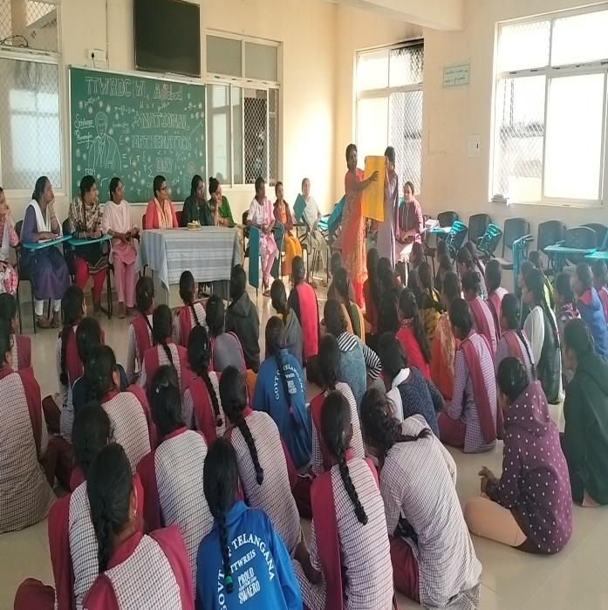

**PG AND EMPLOYABILITY CLASS INTERNAL EXAMS**

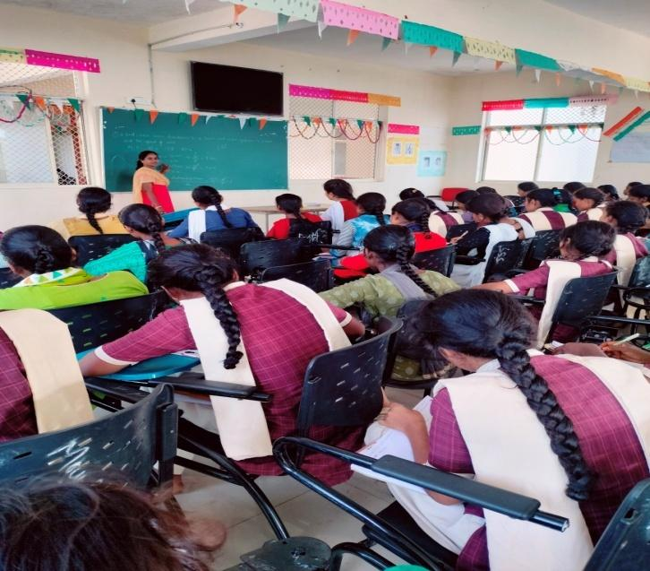 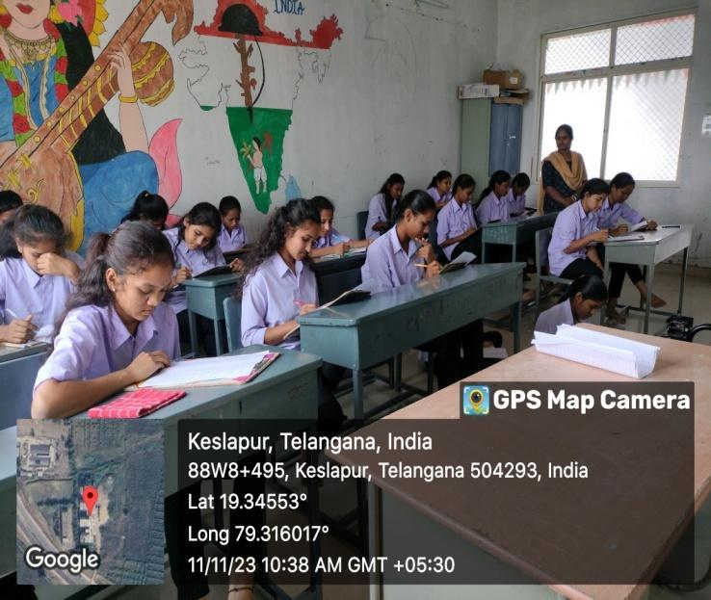

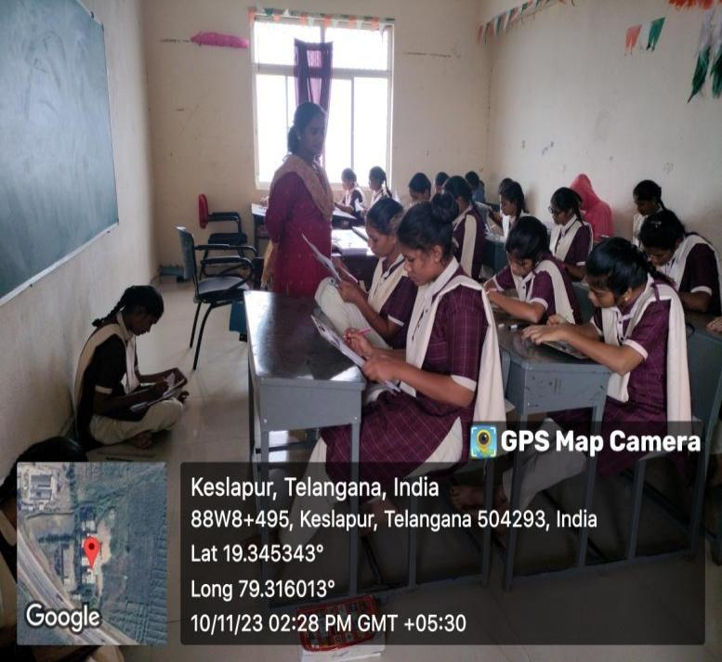 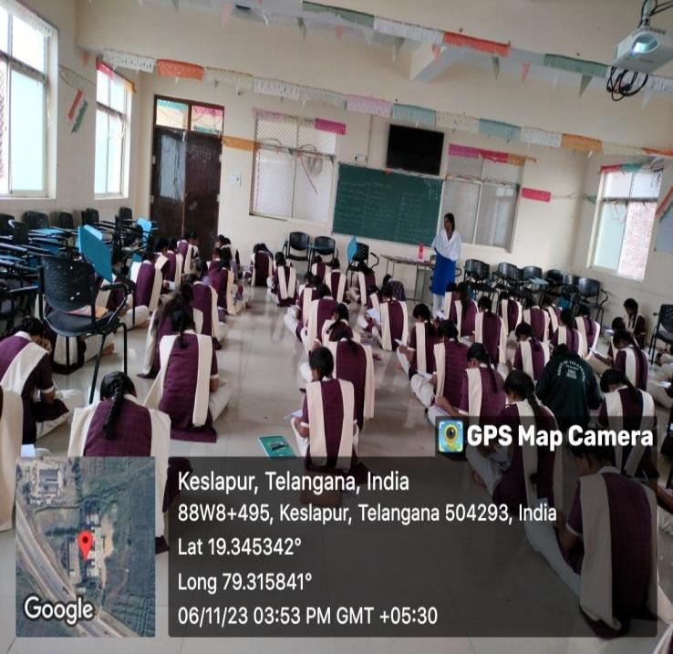

**MOTIVATIONAL CLASS QUEST PROGRAM**

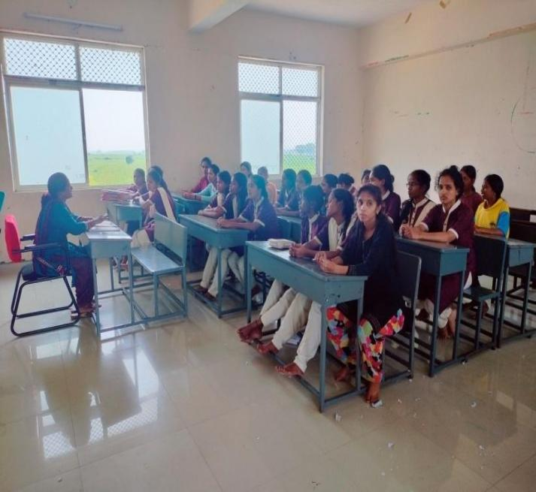 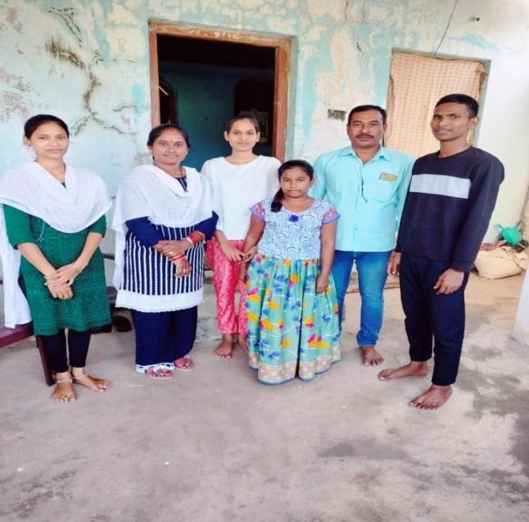

**DEPARTMENTAL MEETINGS**

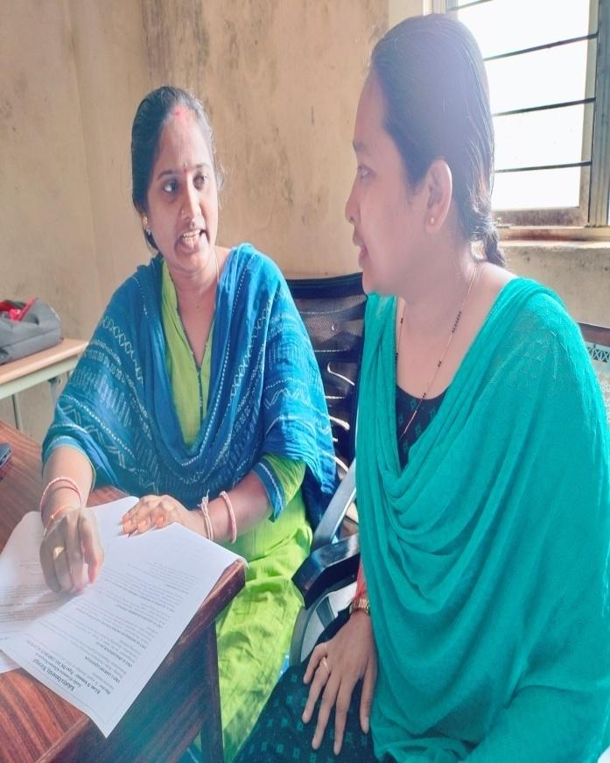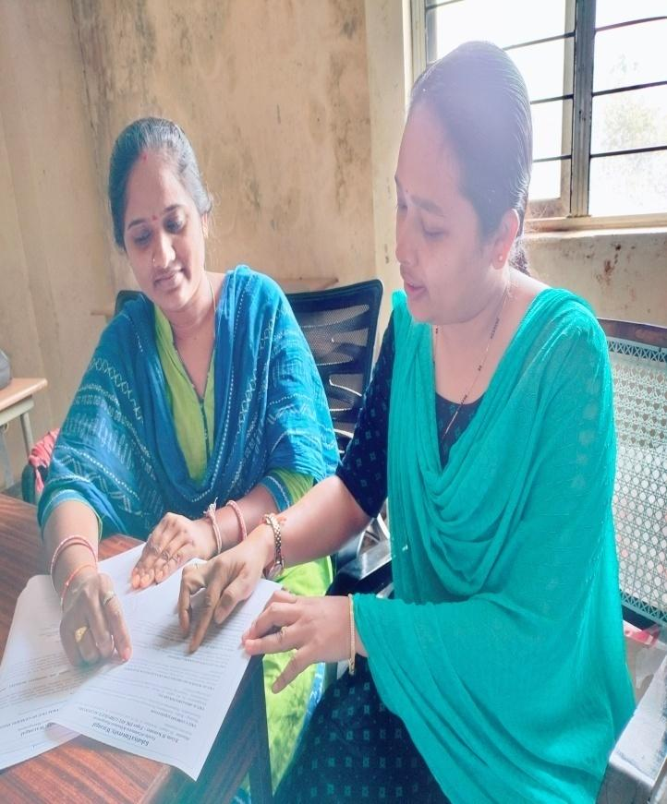

**MATHEMATICS CERTIFICATE COURSE MATHEMATICS WEBINAR**

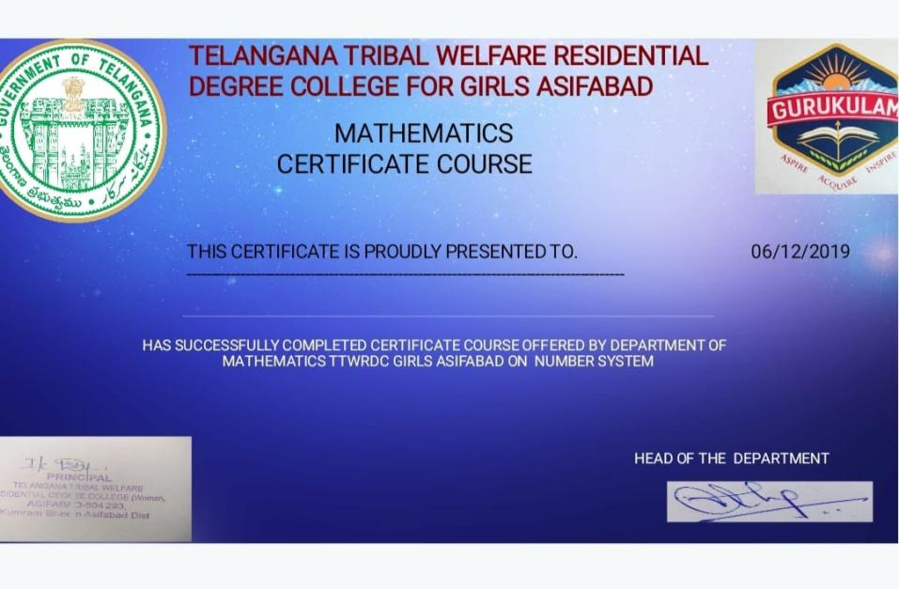 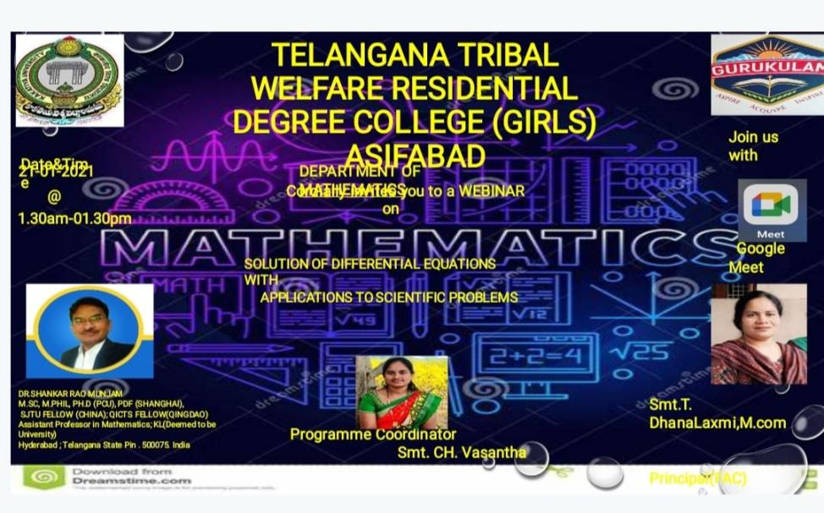

THANK YOU